Bastion Host & Honeypots

Bastion Host :
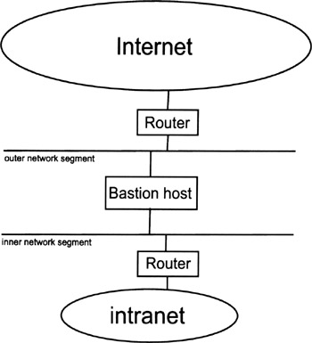

A bastion host is a computer that is fully exposed to attack. The system is on the public side of the demilitarized zone (DMZ), unprotected by a firewall or filtering router.

Frequently the roles of these systems are critical to the network security system.
Due to their exposure a great deal of effort must be put into designing and configuring bastion hosts to minimize the chances of penetration. Other types of bastion hosts include web, mail, DNS, and FTP servers.
A computer system in a network that is fortified against illegal entry and attack, because it is exposed to the outside world (the Internet). Bastion hosts are used for services such as website hosting, mail, DNS lookups and FTP transfer and are located on the public side of a perimeter net (DMZ).
Each bastion host fulfills a specific role, all unnecessary services, protocols, programs, and network ports are disabled or removed. Bastion hosts do not share authentication services with trusted hosts within the network so that if a bastion is compromised the intruder will still not have the authentication to the server.

Hardening The Bastion Host With Single Packet Authorization (SPA) :

The bastion host is key to infrastructure security, it must be hardened. Topic of systems hardening is complex and has many layers. At the network level, an ideal bastion host would be inaccessible (invisible) from an unsecured network unless authenticated and authorized to connect. To accomplish this, alter packet filter rules to permit traffic only from a specific IP address, once have been authenticated via strong (mutually verified) signatures. This is called Single Packet Authorization with Firewall Knock Operator (FWKNOP).

Steps to harden a Bastion Host :

- A bastion host is hardened to limit potential methods of attack.
- Depend upon the intended role of that host as well as the operating system and software that it will be running.
- All appropriate service packs, hot fixes, and patches should be installed.
- Access Control Lists (ACLs) will be modified on the file system and other system objects.
- All unnecessary TCP and UDP ports will be disabled.
- All non-critical services and daemons will be removed.
- Utilities and system configuration tools as is practical will also be removed.
- Logging of all security related events need to be enabled and steps need to be taken to ensure the integrity of the logs so that a successful intruder is unable to erase evidence of their visit.
- Any local user account and password databases should be encrypted if possible.
- Securing whatever network application the host is running.
- Popular network applications also tend to inspire the creation of independent mailing lists, newsgroups, and websites that can be tracked for additional insights.

Honeypots :

A honeypot is a computer system that is set up to act as a decoy to lure cyberattackers, and to detect, deflect or study attempts to gain unauthorized access to information systems.

